**Home Page**



**Visvesvaraya**

**Technological**

**University**

**BELAGAVI**

**,**

**KARNATAKA**

**WEB TECHNOLOGY AND ITS APPLICATION**

**MINI PROJECT REPORT ON**

**CGPA CALCULATOR**

**Submitted by**

**Name**

**USN**

**RUCHITHA S R**

**4JN20CS086**

**SIRI K S**

**4JN20CS101**

**SNEHA S R**

**4JN20CS102**

**VIBHA G M**

**4JN20CS117**

**Under**

**the**

**guidance**

**of**

**Nandish M**

**Professor., Dept. of CS&E**

**JNNCE, SHIMOGA**

Department of Computer Science & Engineering

Jawaharlal Nehru New College of Engineering

Shimoga

-

577

204

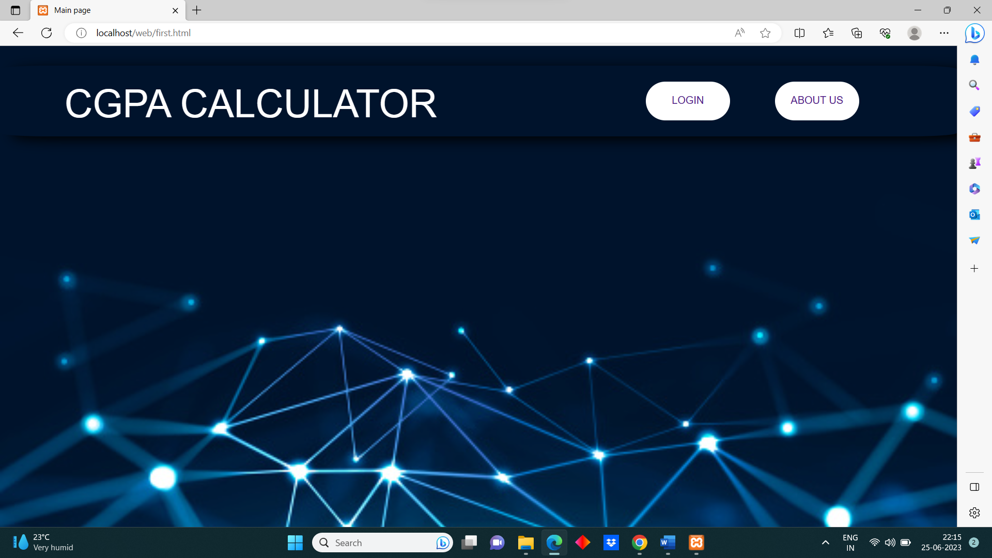

**Login Page**

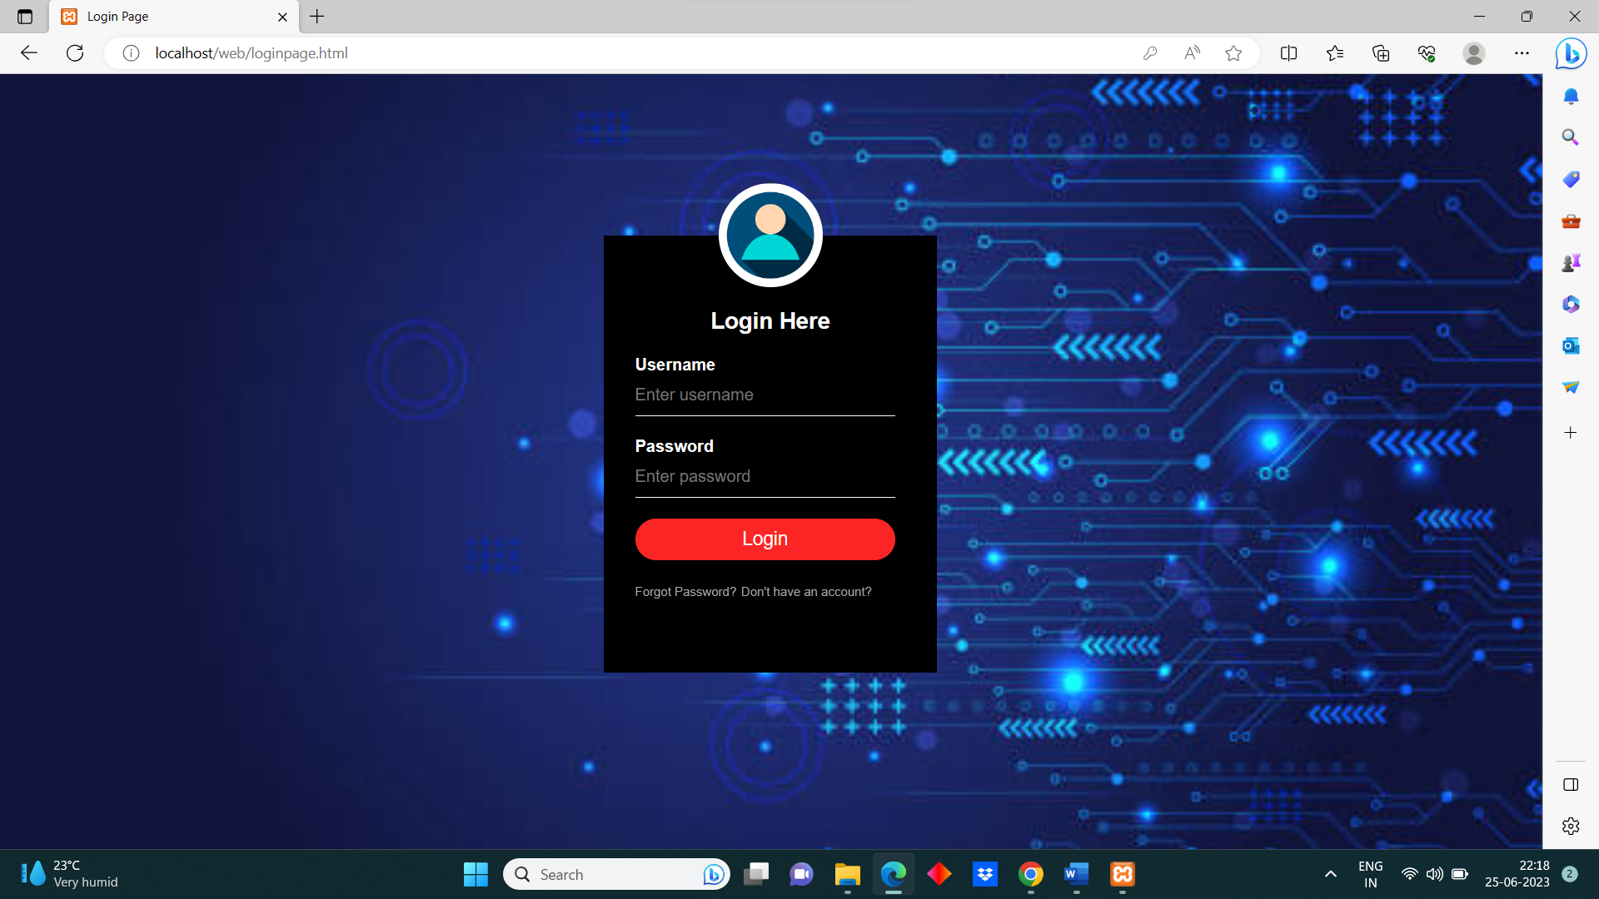

**Signup Page** (Don’t have an account?)

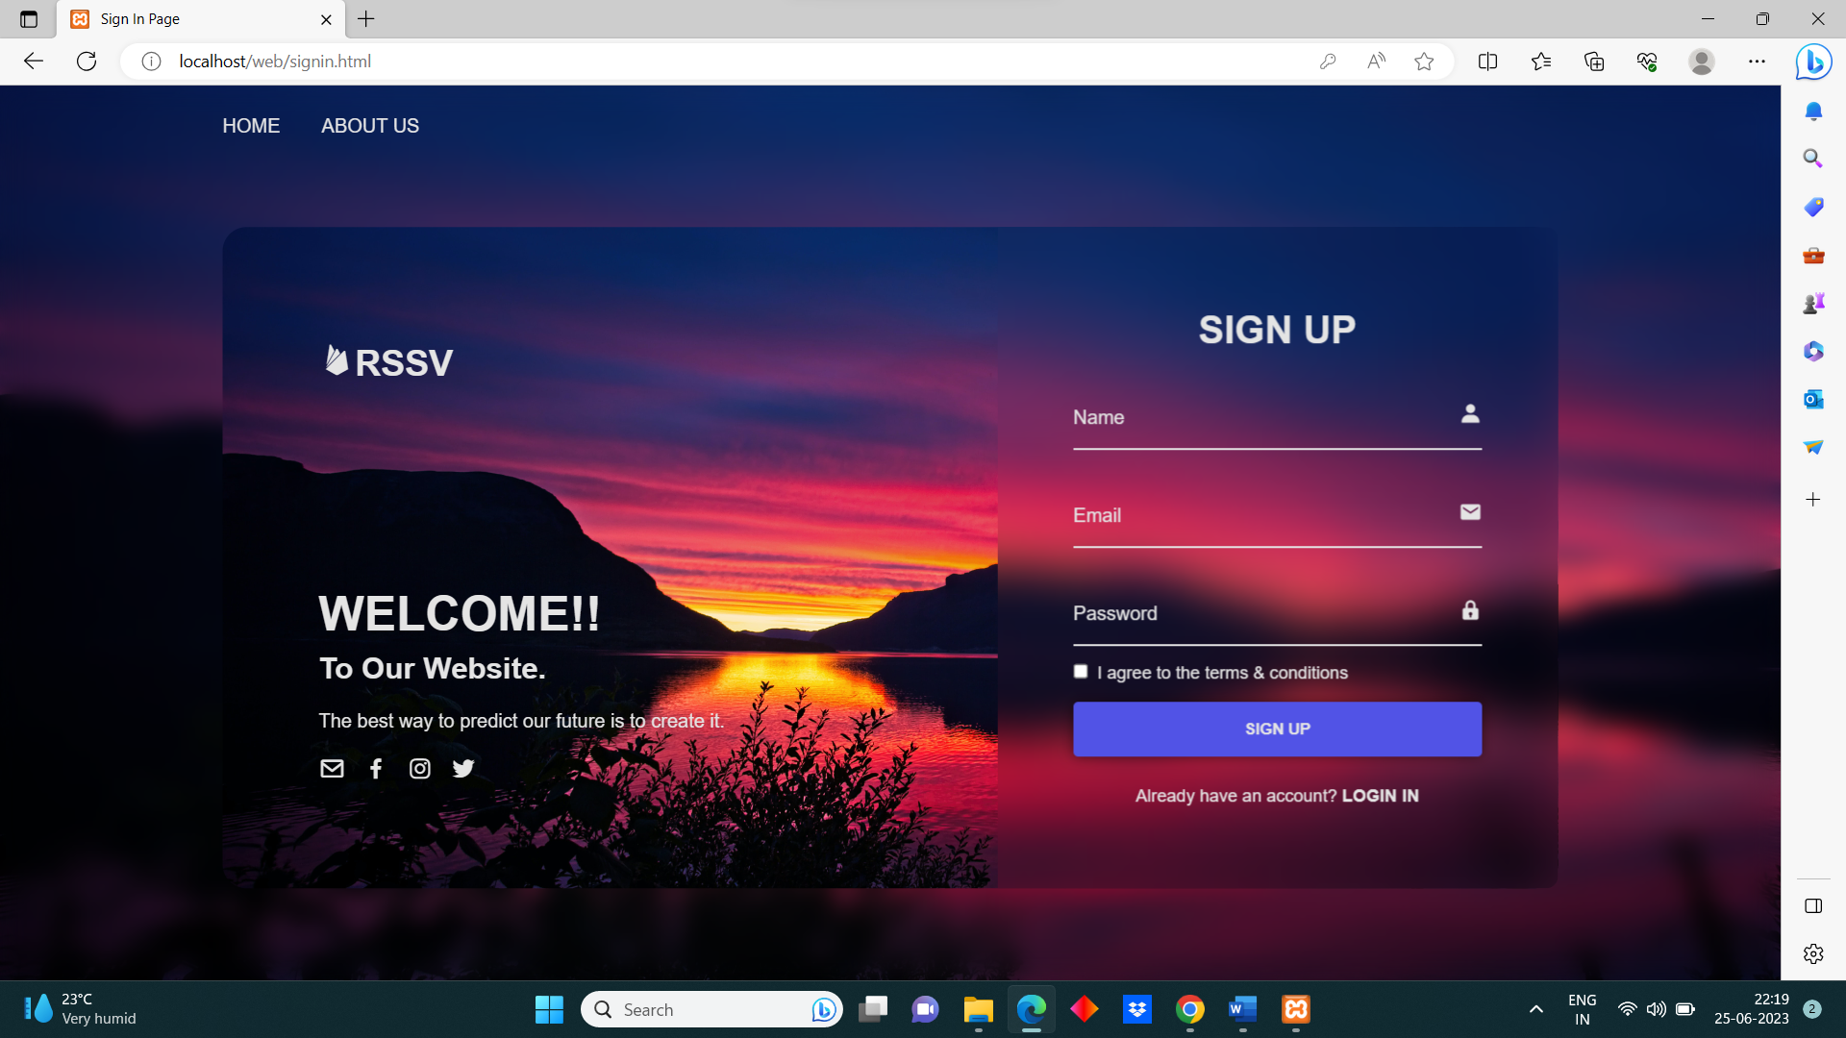

**Forgot Password Page** (Forgot password?)

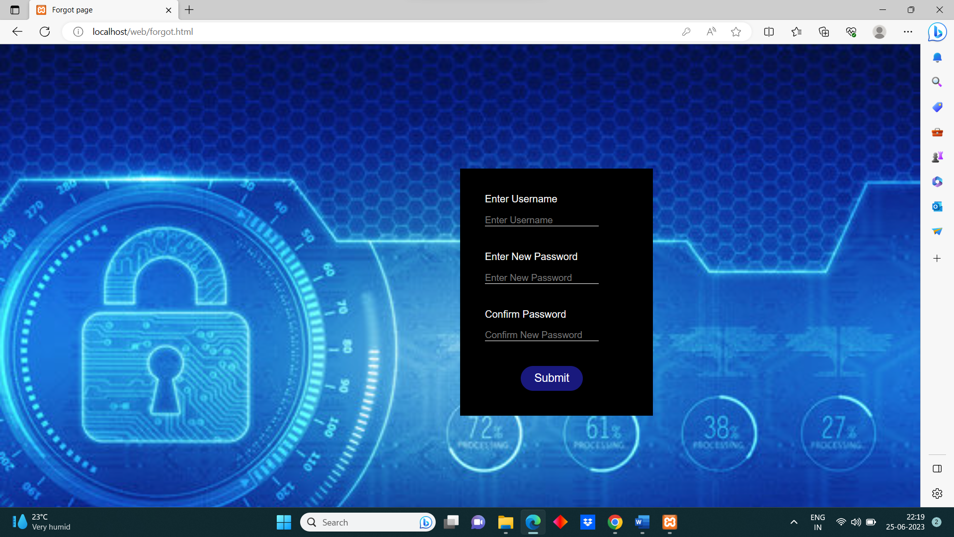

**Invalid Username or password**

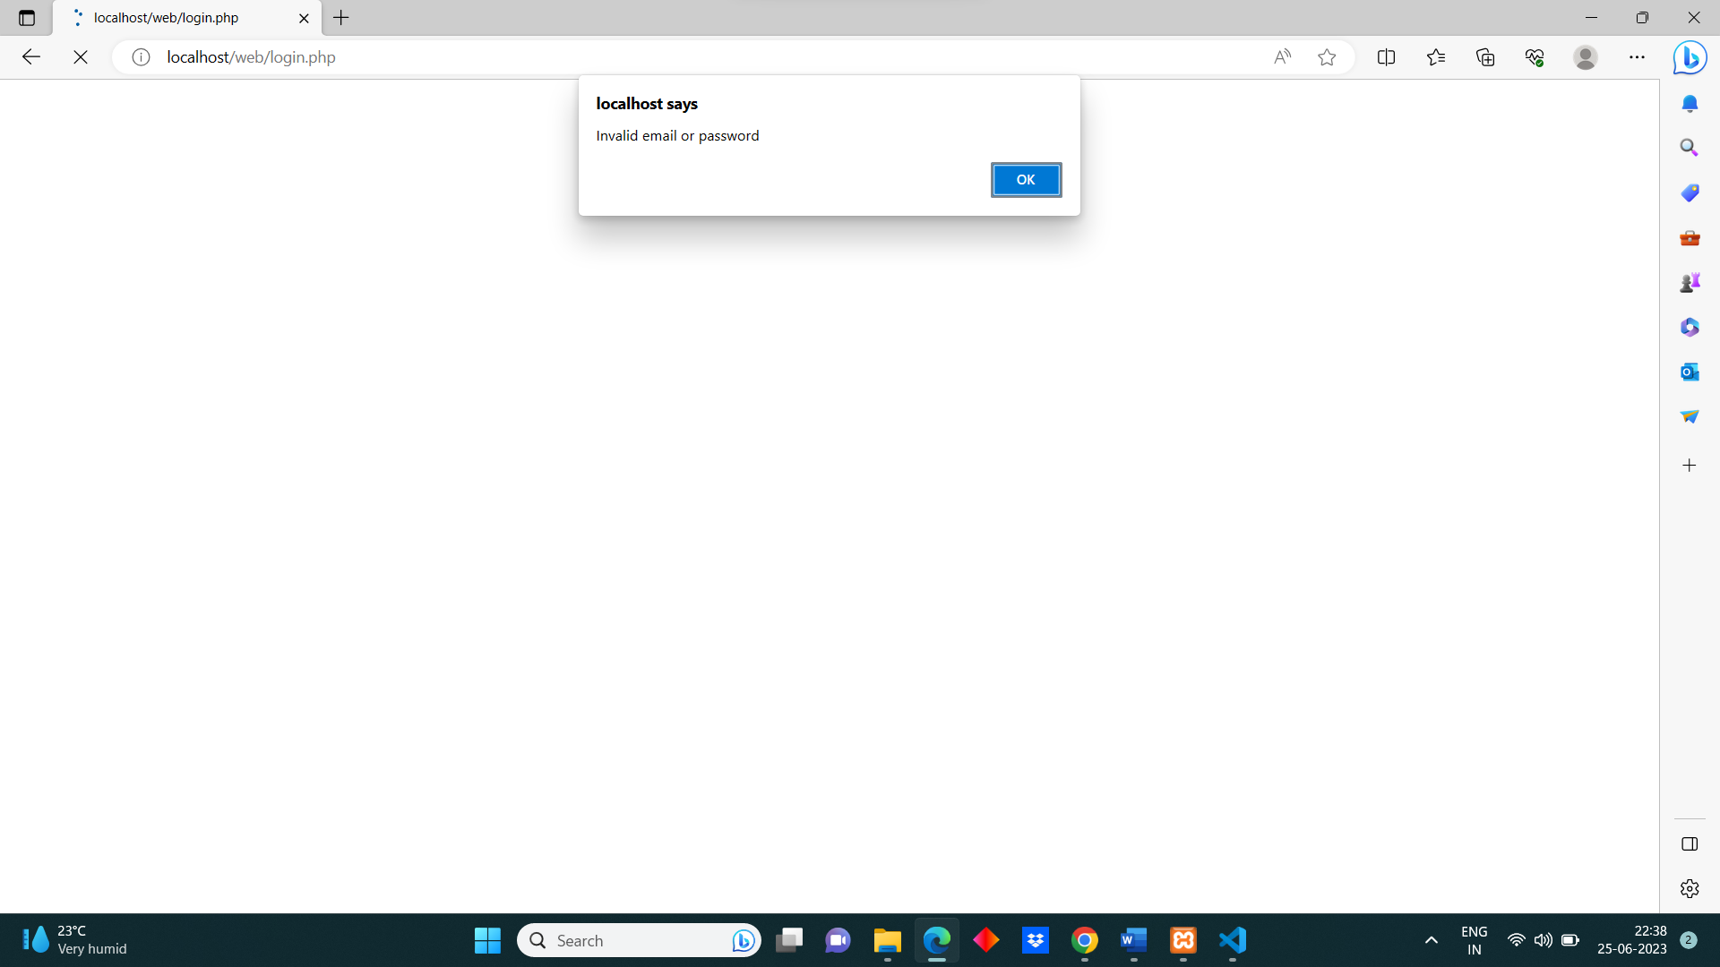

**Valid Username and Password**

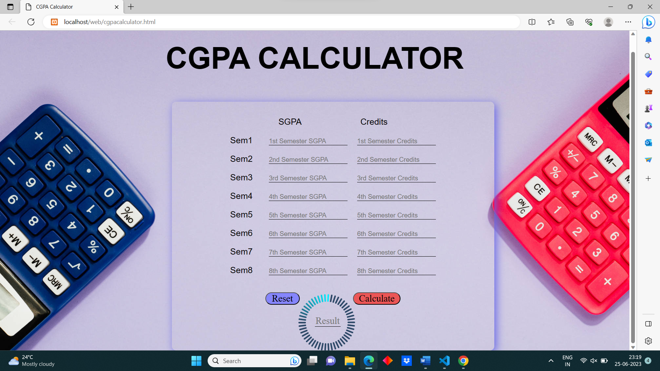

**Calculating CGPA**

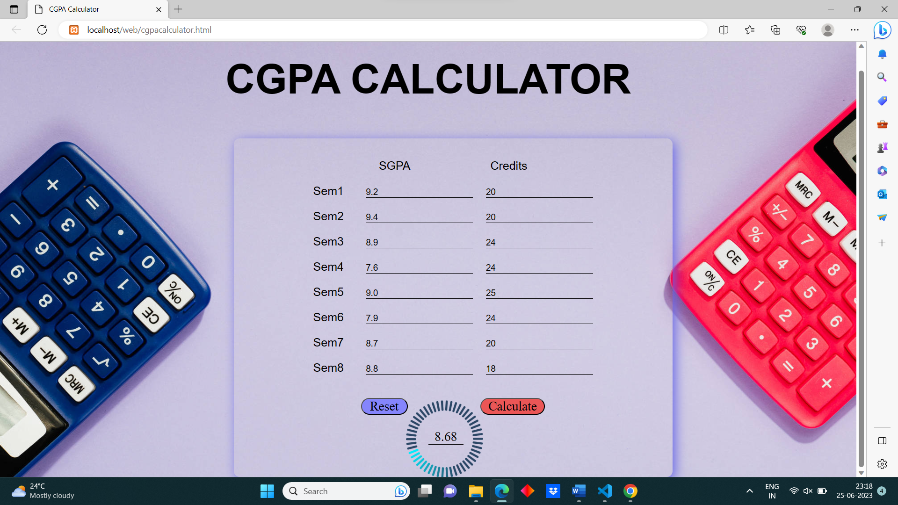

**About-Us Page**

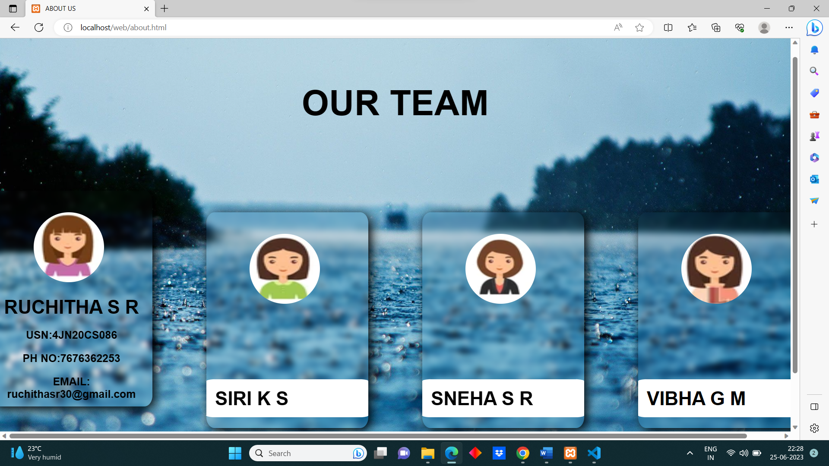

**CODE:**

<!DOCTYPE>

<html>

<head>

<meta charset="UTF-8"/>

<title> Login Page</title>

<link rel="stylesheet” type="text/css" href="login.css">

</head>

<body>

<div class="loginbox">

<img src="log4.png" class="log"/>

<h1>

Login Here

</h1>

<form method="post" action="login.php">

<p>Username</p>

<input type="email" name="email" placeholder="Enter username"/>

<p>Password</p>

<input type="password" name="password" placeholder="Enter password"/>

<input type="Submit" name="login" value="Login"/>

<a href="forgot.html"> Forgot Password? </a>

<a href="signin.html"> Don't have an account? </a>

</form>

</div>

</body>

</html>